**Nuclear Physics – Notes**

**T1/2 =**

**# half-lives = $\frac{log⁡(\frac{N}{N_{0}})}{log⁡(0.5)}$**

**Energy second-1 = Activity (Bq) x energy (J)**

x 1.66 x 10-27

÷ 1.6 x 10-19

u kg J eV

÷ 1.66 x 10-27

x 1.6 x 10-19

m(reactants) < m(products) 🡪 energy has been converted to mass 🡪 energy is absorbed.

m(reactants) > m(products) 🡪 mass has been converted to energy 🡪 energy is released.

Binding energy: The energy required to break a nucleus apart into individual protons and neutrons.

Critical mass: The minimum mass required for the reaction to become a self-sustaining chain reaction occurring at a constant rate.

Super-critical mass: The minimum mass required for the reaction to become a runaway chain reaction occurring at an increasing rate.

Fissile: The property of a nuclide being able to split into 2 nuclei when hit by a neutron.

Z < 20 🡪 n:p of 1:1.

20 < Z < 82 🡪 Slightly more neutrons than protons.

Z > 82 🡪 unstable.

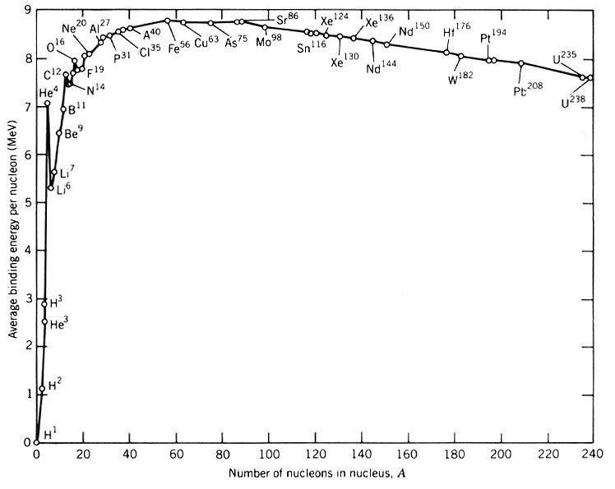

Towards Fe-56 → Becoming **more stable** → Energy is **released** – exothermic.

Away from Fe-56 → Becoming **less stable** → Energy is **absorbed** – endothermic.

Because α particles are much larger than other radiated particles they collide with many atoms, rapidly losing their kinetic energy. These collisions cause lots of ionisation but the rapid loss of energy means that the α particles don’t penetrate very far.

β particles are high-speed electrons or positrons. Their small size means that they lose energy by collisions with atoms less rapidly. Thus, they cause less ionisation but by retaining their energy longer penetrate further.

γ rays are high-energy photons of electromagnetic radiation. They travel large distances through matter without being absorbed and so penetrate very far. When absorption occurs, electrons are emitted, causing ionisation.

An α particle is absorbed in the first centimetre of tissue but causes large amounts of ionisation while doing so. When an α emitter is ingested it can adhere to body tissue where it can cause considerable ionisation damage. External sources are usually promptly washed off, but particles lodged internally may continue to do damage over a long period of time.

Lead is very dense; high-density material absorbs radiation better than low-density material.

Rotating the source around the patient’s body maintains continuous irradiation of the tumour site while minimising the dose to any surrounding healthy tissue. Some damage will always be caused by the beam on its way to the target tissue, but this is now spread over a lot of tissue.

Radiation treatment using a beam of gamma rays won’t make the patient radioactive because gamma photons don’t cause changes in the nuclei of cells and the absorbed gamma photons aren’t themselves radioactive.

Alpha particles are considered a relatively harmless source outside the body due to their inability to penetrate large distances. However, they’re the most ionising form of radiation and as such can cause major cell damage if an alpha source is ingested or inhaled.

Q: Are fast neutrons or slow neutrons more damaging to humans? Explain why.

The effect of radiation on humans is measured in terms of the quality factor. The quality factor for fast neutrons is 10 compared to 3 for slow neutrons. This is because of the higher energy of the fast neutrons and they will therefore be more harmful.

Radon is largely produced within the Earth itself and will therefore be found in soil and rocks.

Radon concentrations where the Earth has been drilled or dug into, or where the Earth has been disturbed, will tend to be highest, so mine sites or areas of recent volcanic activity would be susceptible.

|  |  |  |  |
| --- | --- | --- | --- |
|  | Alpha: | Beta: | Gamma: |
| Charge | +2 | +1/–1 | 0 |
| Mass | 4 | Negligible | 0 |
| Penetration | Less penetrating | Moderately penetrating | Very penetrating |
| Ionisation | Very ionising | Moderately ionising | Not very ionising |
| Particle | Helium-4 nucleus | Electron/positron | Gamma ray |
| Quality factor | 20 | 1 | 1 |
| Speed | 1/10 speed of light | 9/10 speed of light | Speed of light |

Q: Explain in detail how you could determine the type of radiation emitted.

Use the Geiger counter to measure the background radiation and then the activity of the sample at a certain distance. Measure activity at the same distance with some paper in the way. Measure activity at the same distance with aluminium foil in the way. Subtract background radiation from all measurements. If the activity didn’t change, it’s gamma radiation, if the activity decreased a lot with paper, it’s alpha radiation, and otherwise beta radiation.

* The moderator is a material made from water/graphite/heavy water/CO2 that slows down neutrons and speeds up the rate of nuclear fission.
* The control rods are rods made from cadmium/boron steel that absorb neutrons to slow down and control the rate of nuclear fission. They can be inserted and retracted as needed.
* The fuel is enriched to 2.3% uranium-235 so that there’s a high enough concentration to maintain a chain reaction.
* Pipes containing a coolant (liquid sodium/water/CO2/heavy water) collect and divert the heat produced to generate electricity.
* Shielding made out of concrete/lead/graphite/steel reflects and absorbs radiation and the workers are monitored.



Gamma knife:

* Many sources of gamma rays are placed around the head, all aimed at cancer in the brain.
* Each individual beam of gamma rays is too weak to cause significant damage.
* The individual beams intersect at the cancer, so it receives a much higher dose of radiation.

Geiger-Muller tubes:

* An inert-gas-filled tube that briefly conducts electricity when a particle or photon of ionising radiation makes the gas conductive by ionising the gas.
* The tube amplifies this conduction by a cascade effect and outputs a current pulse, which is displayed by a needle, lamp and/or audible clicks.

|  |  |
| --- | --- |
| **Radiation**: | **Quality factor**: |
| Alpha | 20 |
| Beta | 1 |
| Gamma | 1 |
| Slow neutron | 3 |
| Fast neutron | 10 |

1Sv = Severe radiation sickness.

> 1Sv = Good chance of death.

< 1Sv = Mild symptoms.

Q: Describe an experiment to determine the type of radiation emitted.

Place the sample into an electric field with a positively charged plate on one end and a negatively charged plate on the other end and measure the deflection using a Geiger counter or some other measuring device. Alpha radiation will be strongly deflected towards the negatively charged plate. Beta radiation will be moderately deflected towards the positively charged plate. Gamma radiation won’t be deflected at all.

**2 helium-3 nuclei cam fuse to form an alpha particle and 2 protons with the release of 12.98MeV of energy per alpha particle formed.**

**If the reaction could be controlled in a reactor, how much power could be produced from the fusion in one day, of 100g of helium-3 into alpha particles and protons? Use the following masses in your calculations:**

**Helium-3 nucleus = 3.01493 u**

**Helium-4 nucleus = 4.00151 u**

**Proton = 1.00728 u**

**1u = 1.66054 x 10-27 kg**

He + He $\begin{matrix}4 \\ 2\end{matrix}$ He + 2 $\begin{matrix}1 \\ 1\end{matrix}$ H

m(reactants) = 2 x 3.01493 = 6.02986 u

m(products) = 4.00151 + 2 x 1.00728 = 6.01607 u

1.66054 x 10-27

Mass defect = 6.02986 – 6.01607 = 0.01379u 2.29 x 10-29 kg

E = mc2 = 2.29 x 10-29 x (3 x 108)2 = 2.06 x 10-12 J

P = = 2.39 x 10-17 W

1.66054 x 10-27

m(He-3) = 2 x 3.01493 = 6.02986 1.00 x 10-26 kg

#He-3 = = 9.99 x 10-24 particles

P = 2.39 x 10-17 x 2.39 x 10-17 = 2.38 x 108 W = 238 MW

Q: Describe the forces that the proton experiences from other nucleons.

The strong nuclear force causes the proton to be attracted to all other nucleons. It will also experience a smaller electrostatic force between itself and other protons.

Q: Explain why neutrons are better than alpha particles for inducing fission.

Neutrons aren’t charged and so aren’t repelled by other nuclei as alpha particles are.

x 931

u MeV

÷ 931